Bowl with Daffodils by Vincent Van Gogh
The Bowl with Daffodils is among the most famous artworks by Vincent van Gogh from 1882. The meaning of the art is explained in a letter sent to his brother Theo Van Gogh. He described his view of Paris at night as “all grey” with a little black figure and a distinctive white horse that brought out the delicacy of the curious greys. According to him, the key to harmony constitutes a touch of dark combined with a tonal white. The painting also symbolized his message to his brother. He tells his brother that he sees great artistry in him which he needs to cultivate, and allow to grow roots and flowers (Willem, para. 1). Just like the daffodils in a bowl, the growth of his artistry would concentrate and become a significant part of his life.
Danto explains that art can have different meanings and purposes. Some artists choose to use the art for illustrative purposes while others have hidden meanings (Danto, pg. 62). The bowl with daffodils also induces the idea of beauty nourishing from a dark place as part of him sending a message of hope to his brother.
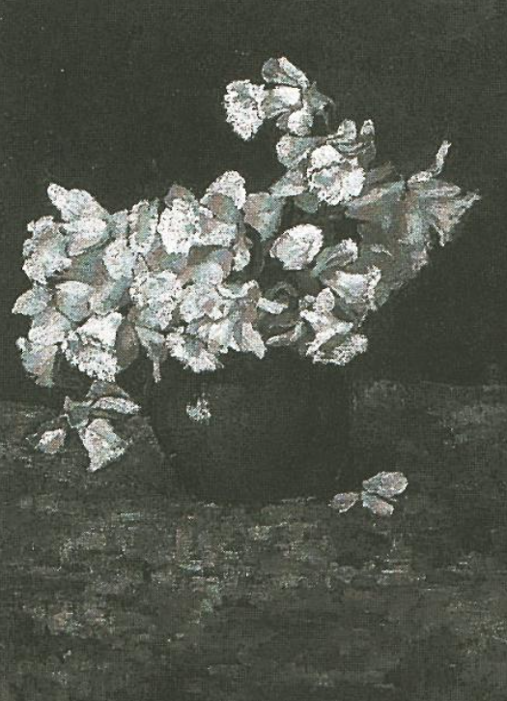

Work cited
Willem, V., 2021. Vincent van Gogh - Bowl with Daffodils 1886 - art-vanGogh.com. [online] Art-vangogh.com. Available at: http://art-vangogh.com/paris_1.html > [Accessed 22 September 2021].

